

University of Bahrain

College of Information Technology

Department of Computer Science

ITCS 389: Software Engineering I

Online Shopping System

**Phase Number:** 1

**Phase Title:** Project Management

**Due Date:** 16/10/2024

**Team Members:**

**Project Manager:**

Shahad Yaser Abdulrahman Nassar 202210309

**Members:**

Maimoona Abdulrahman Alawadhi 202208599

Amal Abdulhameed Ahmed 202204700

Maryam Ali Jama 202107498

# Table of Contents

Table of Contents 2

Chapter 1 | Project Management 3

1.1 Introduction 3

Project Overview 3

Client/Organization 3

Stakeholders 3

1.2 Background 4

Client's Business 4

Existing System 4

Business Goals 4

1.3 Problem Definition 5

Specific Issues 5

Impact Analysis 5

Desired Outcomes 6

1.4 Project Objectives 6

1.5 DevOps Model 7

References 10

# Chapter 1 | Project Management

## 1.1 Introduction

### Project Overview

The Online Shopping System is a comprehensive software designed to make it easier to purchase and sell products and services over the internet. The primary purpose of this project is to provide customers with a user-friendly, safe, seamless, and efficient online purchasing experience, as well as a strong platform for businesses to manage their online sales operations. The project's scope includes creating software that allows customers to register, explore products in the catalogue, add items to cart, make secure payments, track orders, and to provide customer service assistant. The main objectives are to enhance user engagement, simplify purchasing processes, and ensure data security, ultimately leading to increased sales and customer satisfaction.

### Client/Organization

The system is being developed to serve all e-commerce businesses, who are medium-sized retail businesses seeking to increase their market reach via an online platform. They aim to improve their digital presence and give customers an efficient online shopping experience in order to attract a larger audience and boost overall sales performance.

### Stakeholders

The main stakeholders in the Online Shopping System project are:

* Project Sponsors: leadership team who fund and manage the project.
* End-users: Online shoppers.
* Technical team members: developers, designers, and IT support staff members who create, test, and maintain the system.
* Marketing Team: employees who promote the online commerce platform and drives visitors to the site.
* Customer Support Team: Assists people with enquiries and difficulties relating to online purchases.

Collaboration among stakeholders will guarantee the Online buying System satisfies the demands of both the organization and its consumers, leading to a successful digital buying experience.

## 1.2 Background

### Client's Business

The client operates within the e-commerce industry, specifically targeting medium-sized retail businesses. Their operations focus on providing a wide array of products and services through an online platform, allowing customers to shop conveniently from any location. The target market includes tech-savvy consumers who value the accessibility and efficiency of online shopping, ranging from busy professionals to families seeking convenience. By utilizing digital platforms, the client aims to enhance customer engagement and foster long-term relationships with their audience.

### Existing System

Currently, the client employs a mix of manual processes and outdated software to manage their online sales. This includes basic website functionalities that do not integrate well with inventory management, payment processing, or customer service tools. Key limitations of the existing system include:

* User Experience: The current interface is not user-friendly, which can lead to customer frustration. Navigation is often cumbersome, potentially deterring purchases.
* Payment Security: Existing payment methods lack robust security features, raising concerns about data protection and customer trust.
* Order Tracking: Customers face challenges in effectively tracking their orders, resulting in increased inquiries to customer support.
* Inventory Management: Manual inventory tracking processes can lead to discrepancies, negatively impacting sales and customer satisfaction.

These inefficiencies hinder the client's ability to compete effectively in a rapidly evolving digital marketplace.

### Business Goals

The new Online Shopping System is designed to align closely with the client's overarching business goals, which include:

* Enhancing Digital Presence: By implementing a modern, user-friendly platform, the client aims to attract a broader audience and improve brand visibility.
* Increasing Sales: Streamlined purchasing processes and enhanced customer engagement are expected to drive higher conversion rates and boost overall sales performance.
* Improving Customer Satisfaction: The system will provide secure payment options, efficient order tracking, and responsive customer support, leading to a more satisfying shopping experience.
* Data Security: With a focus on security, the new system will ensure that customer data is protected, fostering trust and loyalty.

## 1.3 Problem Definition

### Specific Issues

* Complicated user interface design that does not take into account usability fundamentals
* Listed stock is not consistently updated, leading to inaccurate information about available products
* Quality of items may be inaccurately presented and (for edible products) the expiry date may be incorrect
* Delivery time is not clearly specified and/or may be incorrect
* Inefficient service quality, especially with regards to customer support, which is not always available
* Payment gateways are not always secured and/or may have bugs

### Impact Analysis

* The above issues have the following negative consequences:
* Complex system interfaces are also difficult to traverse for most users; wasting their time with actions that should ideally be quick and effortless
* Mistakenly labeling unavailable products as available may cause issues with orders and therefore lead to unsatisfied customers
* Inaccurate information about the quality of products may lead to unsatisfied customers
* Incorrect delivery information may cause issues when it comes to urgent orders
* Unsecured payment gateways often lead users to fall into phishing attacks and fraudulent transactions

### Desired Outcomes

* To design an easy-to-use system that helps users find their desired products with minimal time and effort
* To develop an easy to maintain system that can be easily updated with up-to-date stock and order information
* To provide users with accurate information about the system, its products, and the user’s order
* To equip the system with a satisfactory customer support service that speedily responds to users’ problems and queries
* To implement secure payment gateways that allow users to safely complete their transactions

## 1.4 Project Objectives

The project aims to achieve the following objectives by the deadline specified in the contract:

* Integrate all business operations, such as selling products, payment, delivery, return policy, customer support, etc., into the online system to be available at any time and any place.
* Minimize the cost and time needed by all business operations.
* Reduce chances of mistakes by humans (customers, staff, administrators) by implementing safety measures and checks into the system.
* Provide accurate real-time statistics for the business operations and generate readable, presentable reports.
* Increase security of operations such as payment.
* Faster response times to customer requests.

These project objectives are well aligned with the goals of online shopping businesses, which aim to increase the ROI and customer sales. These objectives prioritize creating an efficient system that’s easy to use and stable in the long run. The system is made to be attractive to the customer, simple to do processes through, and provides all the processes needed with minimal need for customer support. This should increase the returns of investing in this system and the sales.

## 1.5 DevOps Model

The DevOps iterative model was chosen to meet business objectives in an efficient and rapid manner. Modern tools and solutions are key for a modern system to be developed, deployed, and maintained. Since the system is intended for a quickly changing market and industry, and the fact that the business itself is fundamentally a large-scale online business; a modern and quick lifecycle such as DevOps is needed to fulfill the project objectives. [1]

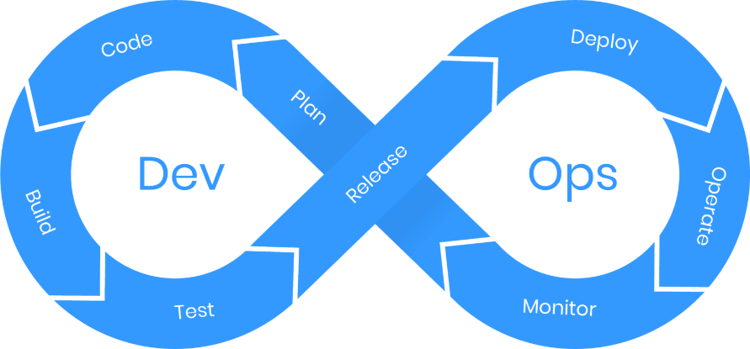

**DevOps** is a collaborative approach to software development and IT operations that aims to shorten and automate the entire software development lifecycle (SDLC) and provide continuous integration, delivery, and feedback, which ensures fast, reliable, and efficient software development and deployment.

DevOps fosters a culture of collaboration between development (Dev) and operations (Ops) teams, promoting automation, continuous improvement and delivering high-quality software faster.

The iterative phases of the DevOps model are as follows:

* **Plan**: Defining requirements and planning the project by collecting end-user feedback, then creating a project roadmap.
* **Code**: Writing and developing code for the features planned in the previous phase.
* **Build**: Automating builds, generate executables, and prepare the software for deployment.
* **Test**: Verify the quality of the code by testing it in various environments.
* **Release**: Prepare the software for deployment and release it to production.
* **Deploy**: Deploy the software to the production environment in an automated and reliable manner.
* **Operate**: Managing infrastructure, scaling, and monitoring production environments.
* **Monitor**: Continuously monitor the application's performance and infrastructure for any issues or potential improvements.

DevOps involves multiple roles across both development and operations, as well as some new roles that are specific to DevOps:

* **Software Developer:** Writes, commits and tests code frequently and collaborates with DevOps engineers to integrate code into the shared repository.
* **Operations Engineer:** Manages infrastructure, deployment, and monitoring and ensuring system availability and performance. In addition, collaborates with DevOps engineers on deployment, scalability, and system maintenance.
* **DevOps Engineer:** Facilitates collaboration between development and operations, and responsible for implementing automation tools and processes and promotes continuous improvement.
* **Quality Assurance (QA) Engineer:** Ensures the quality of the software through writing and automating test cases, analyzes test reports and identifies issues for developers. Works closely with developers and DevOps engineers to ensure continuous testing.
* **Security Engineer:** Protects the application and infrastructure from security threats by ensuring compliance with security standards and conducting penetration testing and security audits.
* **Release Manager:** Oversees the release process and coordinates between development, operations, and stakeholders.

Artifacts in DevOps are the essential deliverables created throughout the DevOps lifecycle, facilitating continuous integration and delivery. These include the source code, which developers produce during the coding phase, and build artifacts, such as executables or libraries compiled during the build process. Deployment scripts automate tasks like deployment through tools such as Docker or Kubernetes. Test reports summarize the outcomes of testing, while release notes document the changes in each release, such as new features or bug fixes. Additionally, monitoring dashboards provide real-time insights into system performance, and logs capture system activity for debugging and monitoring purposes.

**Why is DevOps the ideal choice for this system?**

The DevOps model has been chosen as the process model for this system because it gives clients faster and better results compared to the other models. Because it is based on process automation, continuous collaboration and sharing of feedback between the Development team and the Operations team, the process of implementing code and testing it becomes much faster, and developers can maintain the system and fix its problems (if found) quickly and easily.

This quality is very important for large-scale systems such as online shopping systems, because the clients prefer to receive speedy results when first ordering development of the system, and speedy maintenance should any problems arise. This is different from other models like the Waterfall Model, where implementation of the system occurs very late into the process, and undetected blunders can have terrible effects, making it unideal for large-scale projects.

Merging both the operations and development teams also helps enhance teamwork and collaboration skills by increasing communication between them, leading to a tighter knit work team where there is stronger trust between everyone involved and less misunderstandings.

# References

|  |  |
| --- | --- |
| [1] | "What is DevOps?," 23 5 2021. [Online]. Available: https://www.betsol.com/blog/what-is-devops/. |